Online Appendix A: EFA Solutions

Table 7A.1 Exploratory Factory Analysis Results, with Four Factors
Item | PC | AE | MO | AU | MSA
I prefer politicians who tell it how it is. | .528 |  |  |  | 7
It's important for a political leader to be like the people he or she represents. | .491 |  |  |  | 4
The will of the people should be the highest principle in this country's politics. | .458 |  |  |  | 0
Politicians should spend less time behind their desks, and more among ordinary people. | .458 |  |  |  | 4
What our country needs is a strong, determined President who will crush evil and set us on the right path again. | .441 |  |  |  | 3
Politicians should always listen closely to the problems of the people. | .428 |  |  |  | 7
In a democracy, the will of the majority should prevail. | .414 |  |  |  | 0
I prefer politicians who I feel like I could get to know as a person. | .401 |  |  |  | 4
There is only one relevant division in politics: those who care for the people and those who care only for themselves. | .398 |  |  |  | 5
Political institutions that block the people's will should have no place in politics. | .391 |  |  |  | 0
Our presidents should have the necessary power so that they can act in favor of the national interest. | .387 |  |  |  | 0
Only the people can make our country strong again. | .386 |  |  |  | 1
[country]'s survival depends on us making the right choice in the next elections. | .383 |  |  |  | 5
Elected politicians should always remain loyal to their voters. | .38 |  |  |  | 0
The politicians in Congress need to follow the will of the people. | .378 |  |  |  | 0
I take pride in being an ordinary person. | .376 |  |  |  | 0
Ordinary people's opinions are more honest than that of experts and politicians. | .363 |  |  |  | 4
The best politicians are those who come from the common people. | .346 |  |  |  | 4
What our country needs is a leader who will be respected by other governments. | .343 |  |  |  | 0
Elected officials talk too much and take too little action. | .34 |  |  |  | 1
The leading principle of political decision-making should be common-sense, and not complicated political solutions. | .329 |  |  |  | 0
I prefer politicians who I feel I could sit down and grab a drink with. | .324 |  |  |  | 4
Politicians should never manipulate the people. | .318 |  |  |  | 0
Our political system has been corrupted. | .314 |  |  |  | 1
It is important that elected officials deeply discuss issues before taking action. | .313 |  |  |  | 7
I take no pride in being an ordinary person. | -.319 |  |  |  | 0
There's no such thing as “Real Americans”. | -.322 |  |  |  | 0
Politicians don't have to spend time among ordinary people to do a good job. | -.351 |  |  |  | 0
There's no such a thing as “the will of the people”. | -.374 |  |  |  | 0
The government is pretty much run by a few big interests looking out for themselves. |  | .729 |  |  | 1
Elected politicians sell out to big business. |  | .704 |  |  | 1
Quite a few of the people running the government are crooked. |  | .700 |  |  | 1
Politicians are not really interested in what people like me think. |  | .684 |  |  | 1
International financial institutions colonize our country and accumulate wealth by exploiting the people. |  | .648 |  |  | 1
Big corporations accumulate wealth by exploiting the people. |  | .640 |  |  | 1
Big corporations are the ones really running this country. |  | .630 |  |  | 1
All governments, and the elites that live off them, want to control public opinion. |  | .623 |  |  | 1
The power of a few special interests prevents our country from making progress. |  | .621 |  |  | 1
Our politics is hostage to the interests of a military-industrial complex. |  | .602 |  |  | 1
Members of Congress quickly lose touch with ordinary people. |  | .578 |  |  | 1
The people's demands are ignored in favor of what benefits the establishment. |  | .569 |  |  | 1
The government and the elite it serves are the cause of the people's problems. |  | .569 |  |  | 1
Regardless of the party in power, all governments just favor the bigwigs. |  | .566 |  |  | 1
Politicians seek power for its own sake. |  | .551 |  |  | 1
We shouldn't tolerate all these elected politicians selling out to big business. |  | .533 |  |  | 1
We need to take the country back from the hands of Wall Street. |  | .531 |  |  | 1
The power of a few special interests prevents our country from making progress. |  | .500 |  |  | 1
Politicians do not want to improve the lives of ordinary people. |  | .499 |  |  | 1
Government officials use their power only to mess with people's lives. |  | .474 |  |  | 1
Political differences are larger between the elite and the people than they are among the people. |  | .437 |  |  | 1
Politicians should spend less time thinking of reelection and more working for the people. |  | .437 |  |  | 1
People should stop reelecting politicians who don't care about what we think. |  | .419 |  |  | 1
The rights of individuals have been systematically curtailed in this country. |  | .395 |  |  | 1
People are often manipulated by politicians, and it is wrong. |  | .385 |  |  | 0
Our political system has been corrupted. |  | .368 |  |  | 1
The United Nations is a conspiracy with the goal of destroying nation-states. |  | .367 |  |  | 0
Politicians spend all of their time getting re-elected or reappointed. |  | .364 |  |  | 1
Only the people can make our country strong again. |  | .352 |  |  | 1
Politics is divided between the haves and the have-nots. |  | .350 |  |  | 0
Our presidents should do what the people want even when the laws prohibit him from doing it. |  | .344 |  |  | 0
The people, and not the politicians, should make our most important policy decisions. |  | .340 |  |  | 1
Elected officials talk too much and take too little action. |  | .339 |  |  | 1
I would rather be represented by a citizen than by a professional politician. |  | .333 |  |  | 1
The unemployed, the underemployed, and other marginalized groups - these are the real people, who should have more voice in politics. |  | .317 |  |  | 0
UN leaders want to strip our country of its sovereignty. |  | .304 |  |  | 0
The influence of big money in our politics is overstated. |  | -.309 |  |  | 2
In politics, everyone wants what they think is best for the country. |  | -.316 |  |  | 0
If big corporations accumulate wealth, that's because they produce useful things. |  | -.321 |  |  | 0
[Country]'s survival is not at stake in the next elections. |  | -.345 |  |  | 0
The unemployed, the underemployed, and other marginalized groups already have enough voice in politics. |  | -.362 |  |  | 2
The rights of individuals are highly respected in this country. |  | -.373 |  |  | 2
Our presidents should obey the laws even when the people don’t like it. |  | -.390 |  |  | 0
Big corporations don't have a strong influence on how this country is run. |  | -.418 |  |  | 2
Government officials use their power to try to improve people's lives. |  | -.551 |  |  | 2
The government is currently run for the benefit of all the people. |  | -.562 |  |  | 2
Hardly any of the people running the government are crooked. |  | -.597 |  |  | 2
Politicians are actually interested in what people like me think. |  | -.689 |  |  | 2
You can tell if a person is good or bad if you know their politics. |  |  | .719 |  | 6
I would stop talking to a friend who had unacceptable political opinions. |  |  | .628 |  | 6
The people I disagree with politically are just misinformed. |  |  | .531 |  | 6
The ideals of the people I disagree with politically are devastating for society. |  |  | .463 |  | 6
Hardly any of the people running the government are crooked. |  |  | .450 |  | 2
People I disagree with politically are driven solely by greed. |  |  | .426 |  | 0
Politics is a struggle between good and evil. |  |  | .424 |  | 5
The difference between me and those who support other parties is that I care about what's good for everyone. |  |  | .411 |  | 5
Politicians are actually interested in what people like me think. |  |  | .366 |  | 2
Our country is at a crossroad, and there is only one correct way to go. |  |  | .364 |  | 5
Political decisions made in this country will change the lives of people all around the world. |  |  | .364 |  | 0
In politics, you have to keep your guard up when dealing with people you disagree with. |  |  | .340 |  | 0
What people call 'compromise' in politics is really just selling out on one's principles. |  |  | .332 |  | 0
[Country]'s survival depends on us making the right choice in the next elections. |  |  | .313 |  | 5
Regardless of the party in power, all governments just favor the bigwigs. |  |  | -.312 |  | 1
Quite a few of the people running the government are crooked. |  |  | -.380 |  | 1
People should stop reelecting politicians who don't care about what we think. |  |  | -.396 |  | 1
Politicians should spend less time thinking of reelection and more working for the people. |  |  | -.437 |  | 1
I would never stop talking to a friend because of their political opinions. |  |  | -.630 |  | 0
People who only say bad things about America should not be allowed to conduct even peaceful demonstrations. |  |  |  | .682 | 3
People who only say bad things about this country should not be allowed to appear on television to make speeches. |  |  |  | .675 | 3
People who only say bad things about our form of government, not just the current administration but the system of government, should not have the right to vote. |  |  |  | .608 | 3
Those who only say bad things about America's form of government should not be permitted to run for public office. |  |  |  | .598 | 3
It is necessary for the progress of the country that our presidents limit the voice and vote of the opposition parties. |  |  |  | .550 | 3
People who only say bad things about our country are our worst enemies. |  |  |  | .543 | 3
In this country, liberal intellectuals are the real enemy of the people. |  |  |  | .468 | 3
Judges frequently hinder the work of presidents, and they should be ignored. |  |  |  | .455 | 0
The Congress slows down the work of our presidents, and should be ignored. |  |  |  | .453 | 0
The United Nations is a conspiracy with the goal of destroying nation-states. |  |  |  | .429 | 0
Political institutions should be there to block the people's will. |  |  |  | .407 | 0
In politics, it's enough for me that someone gets the job done; I don't care how or why. |  |  |  | .407 | 0
What our country needs is a strong, determined President who will crush evil and set us on the right path again. |  |  |  | .390 | 3
Politicians might argue but ordinary people agree with each other. |  |  |  | .352 | 0
The so-called division between the haves and the have-nots is really just an illusion. |  |  |  | .351 | 0
The decline in democratic participation is not something we should be worried about. |  |  |  | .350 | 0
I would not object if our country was temporarily ruled by an unelected official to solve difficult problems. |  |  |  | .341 | 0
The influence of big money in our politics is overstated. |  |  |  | .341 | 2
Big corporations don't have a strong influence on how this country is run. |  |  |  | .341 | 2
The unemployed, the underemployed, and other marginalized groups already have enough voice in politics. |  |  |  | .322 | 2
If big corporations accumulate wealth, that's because they produce useful things. |  |  |  | .318 | 0
UN leaders want to strip our country of its sovereignty. |  |  |  | .317 | 0
Politicians should always listen closely to the problems of the people. |  |  |  | -.310 | 7
We should be very concerned about the decline in democratic participation. |  |  |  | -.313 | 7
Sometimes it is necessary to make compromises in politics. |  |  |  | -.334 | 0
In a democracy, minority rights need to be protected even if those views are unpopular. |  |  |  | -.342 | 0
People who only say bad things about our country are still doing something good for our democracy. |  |  |  | -.346 | 8
Our presidents cannot ignore the Congress, even when it delays the work of the president. |  |  |  | -.364 | 0
It is important that elected officials deeply discuss issues before taking action. |  |  |  | -.432 | 7
Our presidents have to permit that the opposition parties enjoy all the liberty to oppose to the president's policies with their voice and vote, even if the opposition parties delay the progress of the country. |  |  |  | -.440 | 8
People who only say bad things about this country have the same right as anyone else to appear on television to make speeches. |  |  |  | -.599 | 8
People who only say bad things about America should have the same right as anyone else to conduct peaceful demonstrations. |  |  |  | -.695 | 0

Online Appendix B: Technical Notes

Number of EFA Factors to Retain

Figure 7A.1
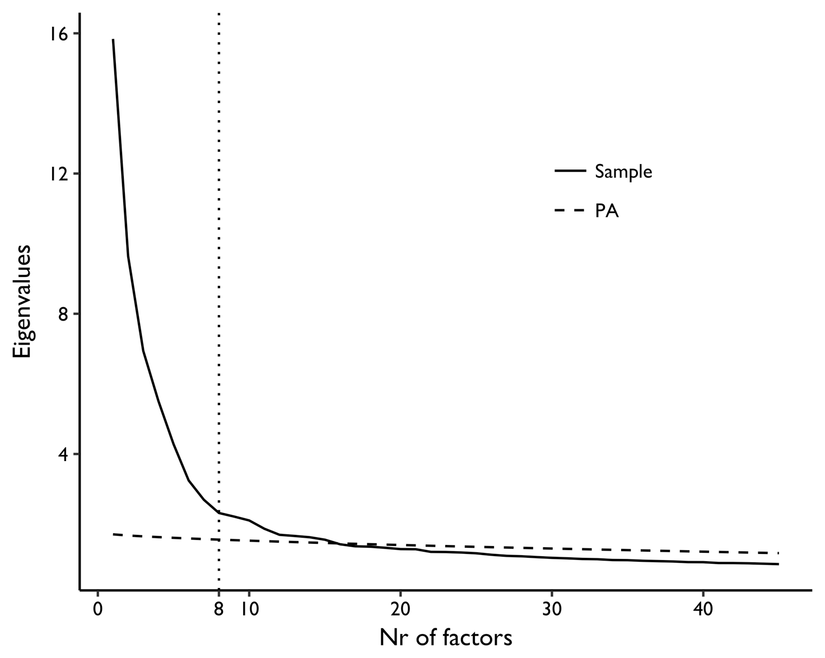

Besides model fit information, we have also explored other alternatives to select the number of factors (m) to retain. A commonly used option is the scree test (Cattell 1966), which suggests looking at a plot of the sample Eigenvalues and select the number of factors before an "elbow" after which the curve flattens out. In Figure 7A.1, this mark seems to be around eight factors, noted with the vertical dotted line. That is where the solid line of observed Eigenvalues becomes more or less flat, after a steep curve from one to five. An alternative that has been proposed is Parallel Analysis (Horn 1965), in which the Eigenvalues of random simulated datasets with the same dimensions as the original (same number of observations and variables), are drawn from a population with no factors. The idea behind this test is that these Eigenvalues are what would be expected by chance. Therefore, the researcher should retain as many factors as there are original Eigenvalues above the simulated ones. As the dashed line in Figure 7A.1 shows, the results of PA for our data would suggest retaining around 15 factors. Another Eigenvalue-based rule of thumb is retaining as many factors as there are Eigenvalues above 1. Yet it is well known that a high number of items inflates Eigenvalues. Indeed, under this rule we would have to go for a solution with 32 factors. Of alternative options with fit indices, we have also looked at incremental ones, in which we compare two models and decide which one fits better (Kline 2016): the Akaike Information Criteria (Akaike 1973) and the Bayesian Information Criteria (Schwarz 1978). Lower numbers indicate better fit. However, both AIC and BIC continued to decrease beyond 12 factors.

Table 7A.2: Model Fit Information for EFA
# of factors | RMSEA | SRMR | AIC | BIC
2 | .052 | .068 | 864997.813 | 868140.473
3 | .047 | .057 | 856554.933 | 860473.761
4 | .042 | .046 | 849662.74 | 854352.306
5 | .039 | .039 | 844940.545 | 850395.423
6 | .037 | .035 | 842052.763 | 848267.524
7 | .035 | .033 | 839882.89 | 846852.106
8 | .034 | .03 | 838138.085 | 845856.33
9 | .032 | .028 | 836676.368 | 845138.213
10 | .031 | .027 | 835209.851 | 844409.868
11 | .03 | .025 | 834357.106 | 844289.868
12 | .029 | .024 | 833618.468 | 844278.547

Online Appendix C: Scale Translations

French

People-Centrism
Ppl1. Les politiciens doivent toujours écouter attentivement les problèmes de la population.
Ppl2. Les politiciens n'ont pas à passer du temps parmi les gens ordinaires pour faire un bon travail.
Ppl3. La volonté du peuple devrait être le principe le plus élevé dans la politique du pays.

Anti-Elitism
Ant1. Le gouvernement est géré par de grands intérêts privés pour leur propre bien.
Ant2. Les membres du gouvernement utilisent leur pouvoir pour essayer d'améliorer la vie des gens.
Ant3. Plusieurs membres du gouvernement sont corrompus.

Manichaean Outlook
Man1. Il est possible de dire si une personne est bonne ou mauvaise en connaissant ses opinions politiques.
Man2. Les gens avec qui je suis en désaccord ne sont pas mauvais.
Man3. Les gens avec lesquels je suis en désaccord sur le plan politique sont simplement mal informés.

German

People-Centrism
Ppl1. Politiker sollten immer genau zuhören, wenn es um die Probleme der Menschen geht.
Ppl2. Politiker müssen keine Zeit mit den ganz normalen Bürgern verbringen, um gute Arbeit zu leisten.
Ppl3. Der Wille des Volkes sollte der wichtigste Grundsatz in der Politik dieses Landes sein.

Anti-Elitism
Ant1. Das Land wird von einigen wenigen grossen Interessengruppen regiert, die sich nur um sich selbst kümmern
Ant2. Regierungsbeamte nutzen ihre Macht, um das Leben der Menschen zu verbessern.
Ant3. Etliche Mitglieder der Regierung sind betrügerisch.

Manichaean Outlook
Man1. Ob eine Person gut oder schlecht ist, kann man beurteilen, wenn man ihre Politik kennt.
Man2. Die Menschen, mit denen ich politisch nicht einer Meinung bin, sind nicht böse.
Man3. Die Menschen, mit denen ich politisch nicht einer Meinung bin, sind bloß falsch informiert.

Portuguese

People-Centrism
Ppl1. Políticos deveriam sempre ouvir com cuidado os problemas do povo.
Ppl2. Os políticos não precisam passar tempo com pessoas comuns para fazerem um bom trabalho.
Ppl3. A vontade do povo deveria ser o princípio mais alto da política neste país.

Anti-Elitism
Ant1. O governo é dirigido por alguns poucos grandes interesses que só se importam consigo mesmos.
Ant2. Os funcionários do governo usam seu poder para tentar melhorar a vida das pessoas.
Ant3. Muitas pessoas no governo são desonestas

Manichaean Outlook
Man1. Dá para saber se uma pessoa é boa ou má se você sabe as opiniões dela sobre política.
Man2. As pessoas que discordam de mim em política não são más.
Man3. As pessoas de quem eu discordo na política são apenas mal informadas.

Greek

People-Centrism
Ppl1. Οι πολιτικοί πρέπει να ακούνε πάντα από κοντά τα προβλήματα του λαού
Ppl2. Οι πολιτικοί δεν χρειάζεται να περνούν το χρόνο τους ανάμεσα στους κοινούς ανθρώπους για να κάνουν καλή δουλειά
Ppl3. Η θέληση του λαού θα πρέπει να είναι η υψηλότερη αρχή στην πολιτική αυτής της χώρας

Anti-Elitism
Ant1. Η κυβέρνηση λίγο πολύ διοικείται από λίγα μεγάλα συμφέροντα που προωθούν τις δικές τους προτιμήσεις.
Ant2. Οι κυβερνητικοί αξιωματούχοι χρησιμοποιούν τη δύναμή τους για να προσπαθήσουν να βελτιώσουν τις ζωές των ανθρώπων
Ant3. Αρκετοί από τους ανθρώπους που βρίσκονται στην κυβέρνηση είναι διεφθαρμένοι

Manichaean Outlook
Man1. Μπορείς να καταλάβεις εάν ένα πρόσωπο είναι καλό ή κακό, αν γνωρίζεις τις πολιτικές του θέσεις
Man2. Οι άνθρωποι με τους οποίους διαφωνώ πολιτικά, δεν είναι κακό
Man3. Οι άνθρωποι με τους οποίους διαφωνώ πολιτικά είναι απλά θύματα παραπληροφόρησης

Hungarian

People-Centrism
Ppl1. A politikusoknak mindig figyelmesen kell hallgatnia az emberek problémáira.
Ppl2. A poltikusoknak nem kell az átlagemberek körében tölteni az idejüket ahhoz, hogy jó munkát végezzenek.
Ppl3. Az emberek akaratának kellene lennie a legmagasabb szintű elvnek országunk politikáját illetően.

Anti-Elitism
Ant1. A kormányt jószerével néhány nagy, saját magával törődő érdekcsoport irányítja.
Ant2. A kormány tagjai és tisztségviselői az emberek életének javítására használják hatalmukat.
Ant3. A kormányt irányító emberek közül elég sok tisztességtelen.
Manichaean Outlook
Man1. Meg lehet mondani egy emberről, hogy jó vagy rossz, pusztán az alapján, ha tudjuk, politikailag hol áll.
Man2. Azok, akikkel politikailag nem értek egyet, még nem gonosz emberek.
Man3. Azok az emberek, akikkel politikailag nem értek egyet csak rosszul tájékozottak.

Italian

People-Centrism
Ppl1. I politici dovrebbero sempre ascoltare attentamente i problemi delle persone.
Ppl2. I politici non devo passare il tempo tra la gente comune per fare un buon lavoro.
Ppl3. La volontà del popolo dovrebbe essere il principio più importante della politica di questo paese.

Anti-Elitism
Ant1. Il governo è gestito da pochi grandi interessi che pensano solo al proprio tornaconto.
Ant2. I funzionari di governo cercano con il loro potere di migliorare la vita alle persone.
Ant3. Parecchie persone che stanno al governo sono disoneste.

Manichaean Outlook
Man1. Puoi dire se una persona è buona o cattiva dalle sue idee politiche.
Man2. Le persone con cui non vado d'accordo politicamente non sono cattive.
Man3. Le persone con cui non vado d'accordo politicamente sono solo disinformate.

Spanish

People-Centrism
Ppl1. Los políticos siempre deben escuchar con atención los problemas del pueblo.
Ppl2. Los políticos no necesitan pasar tiempo con la gente corriente para hacer un buen trabajo
Ppl3. La voluntad del pueblo debería ser el principio más elevado de la política de este país.

Anti-Elitism
Ant1. El gobierno está dirigido en gran medida por unos pocos grandes intereses que miran por si mismos.
Ant2. Los cargos del gobierno utilizan su poder para intentar de mejorar la vida de la gente.
Ant3. Muchas de las personas que dirigen el gobierno son deshonestos.

Manichaean Outlook
Man1. Puedes saber si una persona es buena o mala conociendo su postura política.
Man2. Las personas con las que discrepo políticamente no son malas.
Man3. Las personas con las que discrepo políticamente sólo están mal informadas.

Dutch

People-Centrism
Ppl1. Politici moeten altijd goed luisteren naar de problemen van de mensen
Ppl2. Politici moeten niet meer tijd spenderen tussen gewone mensen om goed werk te leveren.
Ppl3. De wil van het gewone volk zou het grondbeginsel van de politiek in dit land moeten zijn.

Anti-Elitism
Ant1. De regering wordt geleid door een paar belanghebbenden die enkel voor zichzelf zorgen
Ant2. Regeringsleden gebruiken hun macht alleen om het leven van de mensen te verbeteren.
Ant3. Heel wat regeringsleiders zijn oneerlijk

Manichaean Outlook
Man1. Aan de hand van iemands politieke voorkeur weet je of iemand goed of slecht is
Man2. De mensen waarmee ik politiek van mening verschil zijn niet slecht
Man3. De mensen waarmee ik politiek van mening verschil zijn gewoon verkeerd geïnformeerd

Croatian

People-Centrism:
Ppl1. Političari trebaju uvijek pažljivo slušati probleme ljudi.
Ppl2. Političari ne trebaju provoditi vrijeme među običnim ljudima da bi dobro radili.
PPl3. Volja naroda treba biti najviše načelo u politici ove države.

Anti-Elitism:
Ant1. Vlada radi samo na korist nekoliko krupnih interesnih grupa koje brinu samo o sebi.
Ant2. Vladini dužnosnici koriste svoju moć kako bi unaprijedili živote ljudi.
Ant3. Malo tko od ljudi koji vode vladu je pokvaren.

Manichaean Outlook:
Man1. Jasno je je li netko dobar ili loš na temelju toga koju politiku podržava.
Man2. Ljudi s kojima se politički razilazim nisu zli.
Man3. Ljudi s kojima se politički ne slažem su samo neinformirani.

200 iterations, eigenvalues of the sample correlation matrix (principal components).
However, AIC has been criticized for selecting overcomplex models as N increases (see Bozdogan 2000).

